**THEORY:**

**Learning objective:**

This theory and simulated experiment meet the following objectives to be clear:

1. Understanding of centrifugal governor
2. Calculation of the Porter governor height for a rotational speed
3. The advantage over Watt governor
4. The trend of governor height over a varying rotational speed

**Introduction:**

Governors, in general, are most useful means of controlling or regulating the speed of an engine based on varying levels of the load at the output. Though the concept of governors and flywheels are many times misunderstood, both act for a different set of purposes. While the former regulates the speed considering the variations seen in the loading conditions, the latter regulates the speed due to the variations are seen in the engine due to moment fluctuations. Think of the governors from its usefulness. They are used in regulating the speed of the engine, which takes to the fact that the fuel injected is based on the speed variations seen along the shafts

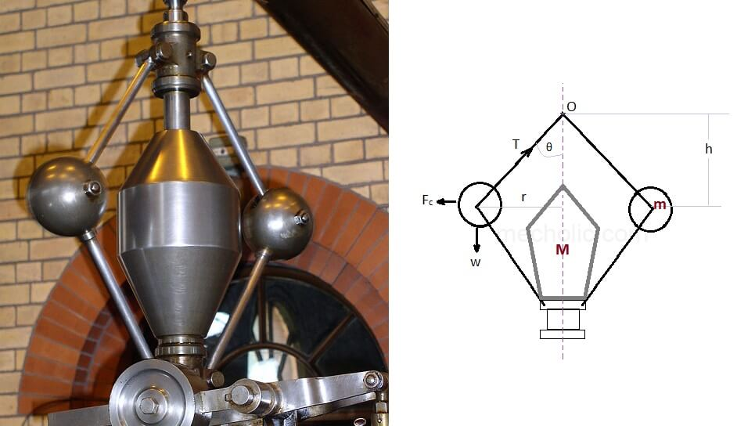

(Ref: https://www.mecholic.com)

Porter governor is a kind of dead weight gravity controlled centrifugal governor. It is similar to Watt governor a slight modification has been done by adding a heavy central load. The centrifugal governor works on the principle of centrifugal force, which gets applicable on the rotating balls. These balls are known as fly balls, which is attached to the spindle through links. The balls rotate with a spindle which is rotated by the engine through a bevel gear.

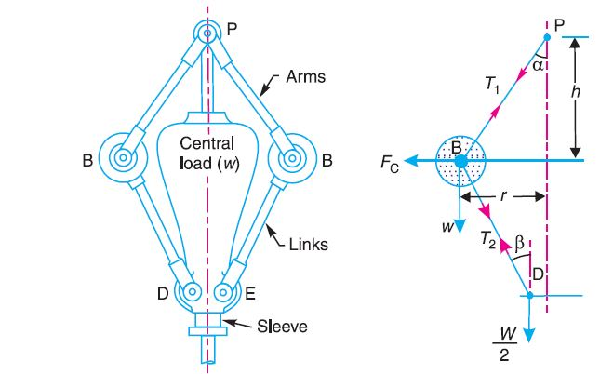

Figure 1 Porter governor

**KIND OF CONFIGURATION:**

Above picture (fig.1) is not the only configuration for any centrifugal governor. Height 'h' mainly depends on the point where both arms intersect.

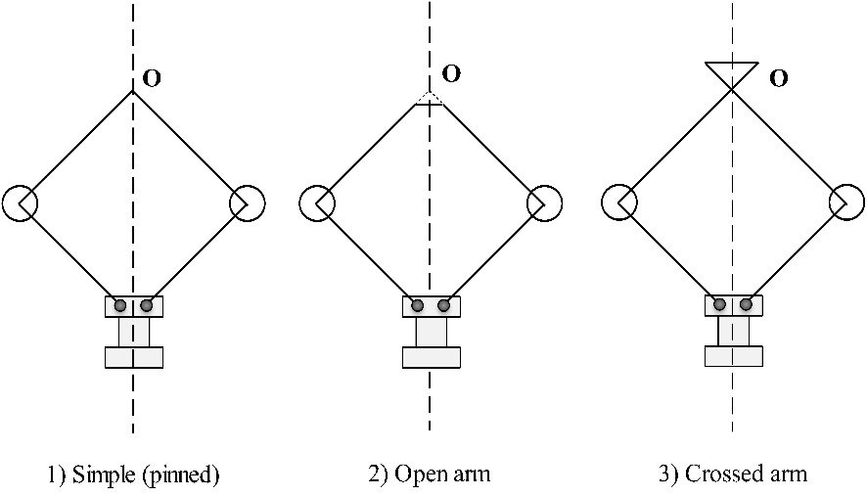

Figure 2 Various configuration of Porter governor

**Mathematical equation:**

*m* = Mass of each ball (kg)

*W* = Weight of each ball = m*g (N)

*M* = Mass of central load (N)

*r* = Radius of rotation (m)

*h* = Height of governor (m)

*ω* = Angular speed of the ball in (rad/s)

*Fc* = Centrifugal force acting on the ball (N)

*T1* = Tension in the arm (N)

*T2* = Tension in the link (N)

*α* = Angle of inclination of the arm (rad)

*β* = Angle of inclination of the link (rad)

Using method of resolution of forces:

Considering the equilibrium of the forces acting at D, we have

$$T_{2}\cos{β}= \frac{Mg}{2}$$

${⇒T}_{2}= \frac{Mg}{2\cos{β}}$…............................................................... (1)

Again, considering the equilibrium of the forces acting on B Resolving the forces vertically

$T_{1}\cos{α}= T_{2}\cos{β}+W=\frac{Mg}{2}+mg$….................................. (2)

Resolving the forces horizontally

$$T_{1}\sin{α}=T_{2}\sin{β}=Fc$$

$$T_{1}\sin{α}+\frac{Mg}{2\cos{β}}\sin{β}=Fc$$

$$T_{1}\sin{α}+\frac{Mg}{2}\tan{β}=Fc$$

${⇒T}_{1}\sin{α}=Fc-\frac{Mg}{2}\tan{β}$…........................................... (3)

Dividing equation (3) by (2)

$$\frac{T_{1}\sin{α}}{T_{1}\cos{α}}=\frac{Fc-\left(\frac{Mg}{2}\tan{β}\right)}{\frac{Mg}{2}+mg}$$

$$\frac{Mg}{2}+mg=\frac{Fc}{\tan{α}}-\frac{Mg\tan{β}}{2\tan{α}}$$

Substituting

$$\frac{\tan{β}}{\tan{α}}=q and \tan{α}= \frac{r}{h}$$

We have,

$$\frac{Mg}{2}+mg=mω^{2}rh-\frac{Mg}{2}q$$

$$h= \left[mg+\frac{Mg}{2}(1+q)\right]\frac{1}{mω^{2}}$$

$⇒h= \frac{\left[mg+\frac{Mg}{2}(1+q)\right]}{m}$…................................................... (4)

$ω^{2}$ = $\frac{\left(m+\frac{M}{2}\right) (1+q)}{m}$ $\frac{g}{h}$

$N^{2}$ = $\frac{\left(m+\frac{M}{2}\right) (1+q)}{m}$ $\frac{895}{h}$…................................................... (5)

Where,

$$ω=\frac{2πN}{60}$$

$$g=9.81m/{s^{2}}$$

When the length of arms is equal to the length of links and the point P and D lies on the same vertical line, then

$$\tan{α}=\tan{β}⇒q=1$$

$$N^{2}=\frac{m+M}{m}×\frac{895}{h}$$

is the required equation.

**Comparison with Watt governor?**

As we know that Watt governor controlling equation is given by $h=\frac{895}{N^{2}}$

We see from the above expression that the height of a governor *h* is inversely proportional to N2. Therefore at high speeds, the value of *h* is small. At such speeds, the change in the value of *h* corresponding to a small change in speed is insufficient to enable a governor of this type to operate the mechanism to give the necessary change in the fuel supply. This governor may only work satisfactorily at relatively low speeds *i*.*e*. from 60 to 80 rpm.

**Procedure:**

1. The schematic of a porter governor in front view as well as in top view is shown

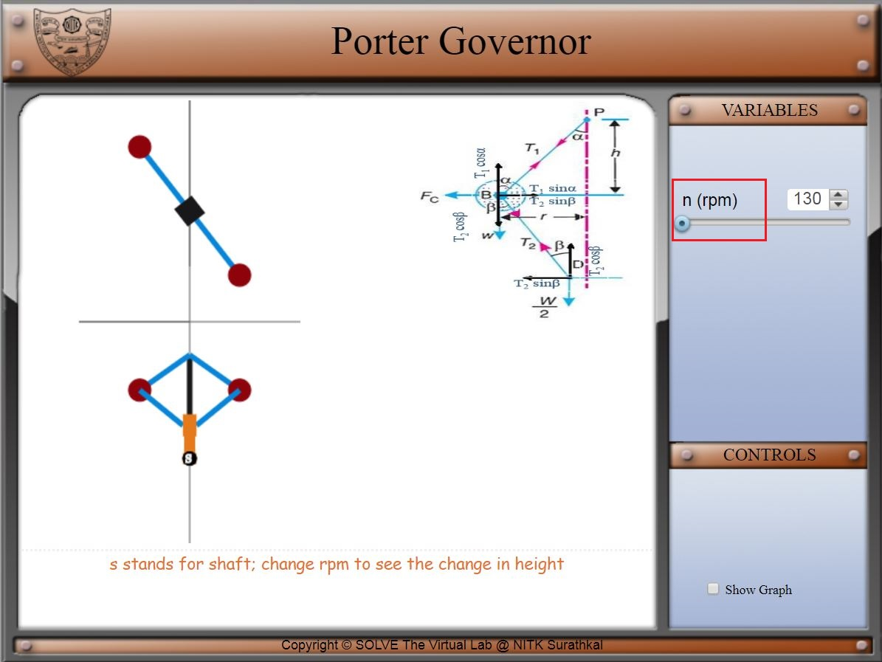

1. On the right top corner of simulation window, there is a slider which allows the change in speed of governor.
2. Observe the governor during the change of speed. The sleeve moves up when there is an increase in speed and goes down when there is a decrease in speed.
3. On the bottom left there is a checkbox “Show Graph”. Click on that graph and the trend of governor height with respect to speed is displayed

